To Whom it May Concern,

I believe that the determination that no responsive records exist is incorrect.

The Federal Reserve has, in the past, had geographic identifiers from the 1977 SCF and made them available to researchers. Below, images "Chatterji Seamans (2012)” and “Zinman (2002)” contain excerpts from two academic papers which have used state of residence data from the 1977 SCF. I have spoken with authors of both papers, who confirm that state of residence of 1977 SCF respondents was available to them at the time they wrote those papers, but they no longer have retained the data.

At the very least, I believe that records must exist which can identify the Principal Survey Unit (PSU) that administered each individual survey in the 1977 SCF, which would be sufficient to satisfy my request. The Principal Survey Units are publicly available in all SCFs prior to 1977, including 1971. Below image “PSUs from 1971 SCF” shows the description of the PSUs in the 1971 SCF. I believe that the Federal Reserve’s internal records from the administration of the 1977 SCF would contain this information. Below image “Sample Address Summary from 1977 SCF”, which is a screenshot from the 1977 SCF codebook, shows that this information was collected in the 1977 SCF – in this sample address summary, the PSU is shown as “Pulaski”. Records for the PSU (e.g. “Pulaski”) of respondents from the 1977 SCF would be sufficient to satisfy my request.

Kindly,
Joseph

Abstract of “Chatterji & Seamans (2012)”
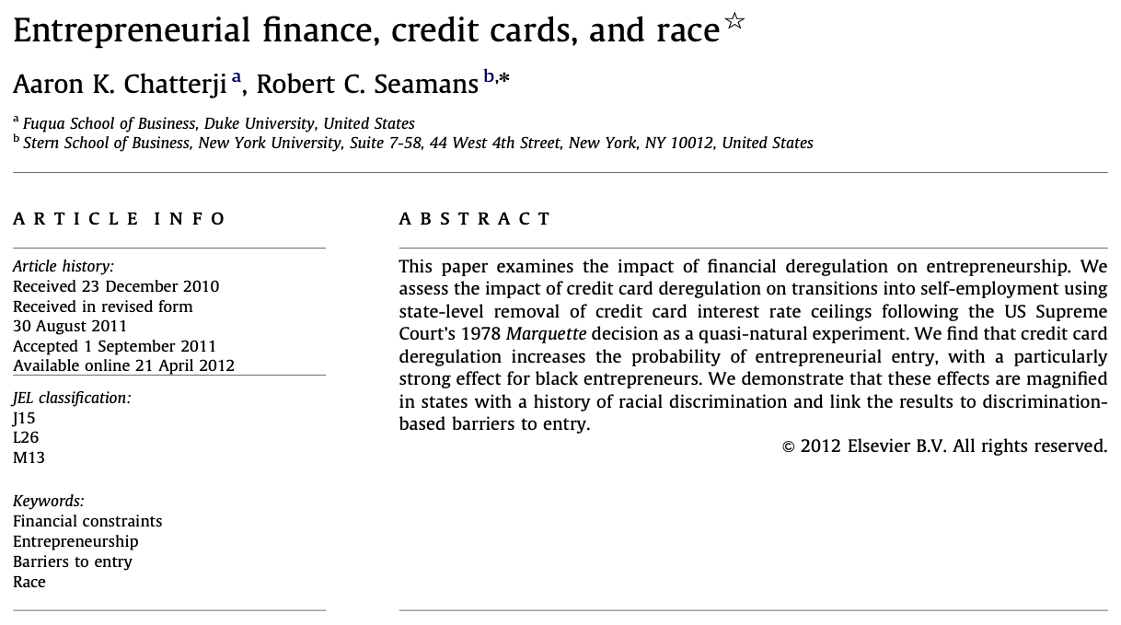
Table 9 of “Chatterji & Seamans (2012)”
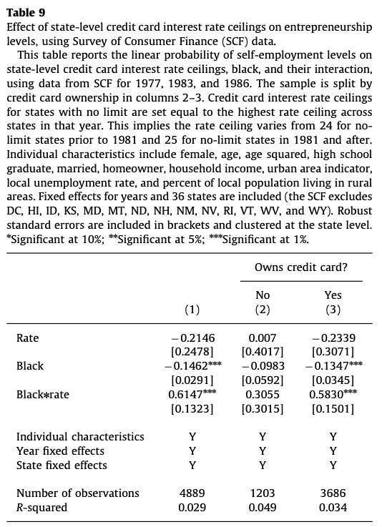
Abstract of “Zinman (2002)”:
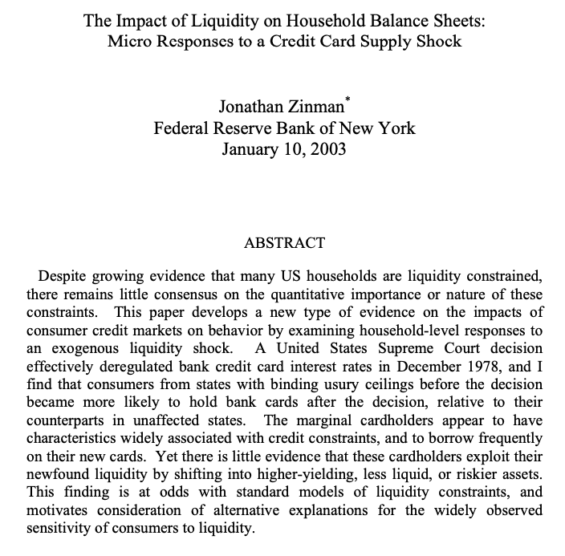
Excerpt of “Zinman (2002)”
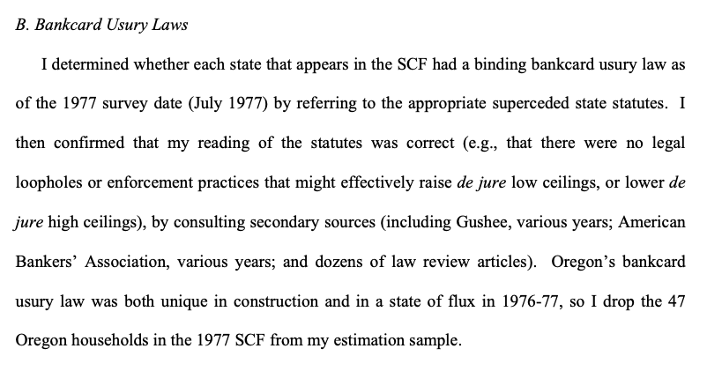

PSUs from 1971 SCF
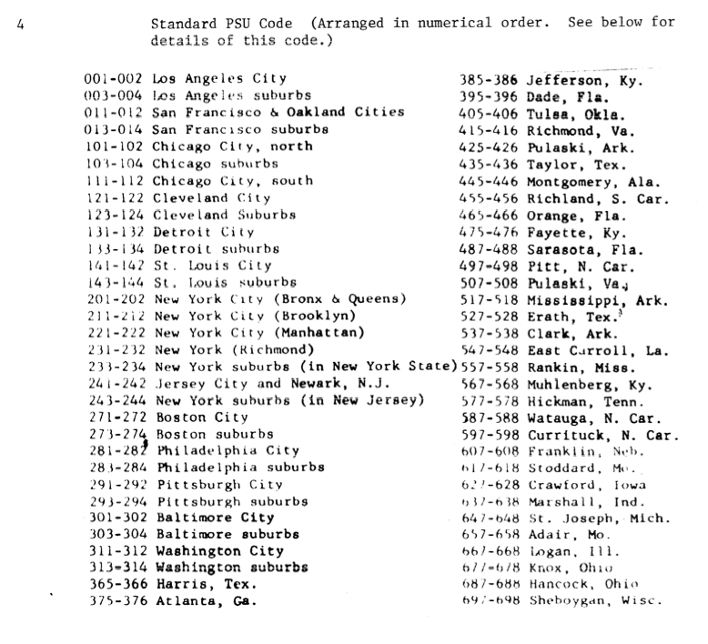

Sample Address Summary with PSU from 1977 SCF
